**GOVERNMENT ARTS COLLEGE FOR WOMEN, SALEM-8**



**DEPARTMENT OF COMPUTER SCIENCE**

**EARLY PREDICTION FOR CHRONIC KIDNEY DISEASE DETECTION: A PROGRESSIVE APPROACH TO HEALTH MANAGEMENT**

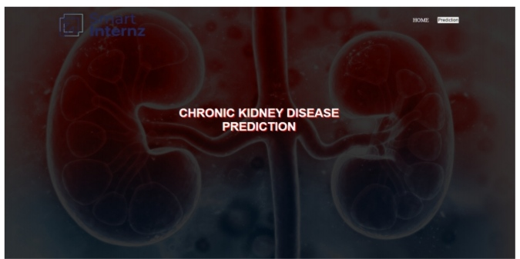

**REPORT**

1. **INTRODUCTION**
   1. **Overview**

Chronic Kidney Disease (CKD) is a major medical problem and can be cured if treated in the early stages. Usually, people are not aware that medical tests we take for different purposes could contain valuable information concerning kidney diseases.

* 1. Purpose

**In todays world as we know most of the people are facing so many disease and  as this can be cured if we treat people in early stages this project can use a pretrained model to predict the Chronic Kidney Disease which can help in treatments of peoples who are suffer from this disease.**

1. PROBLEM DEFINITION & DESIGN THINKING
   1. Empathy map

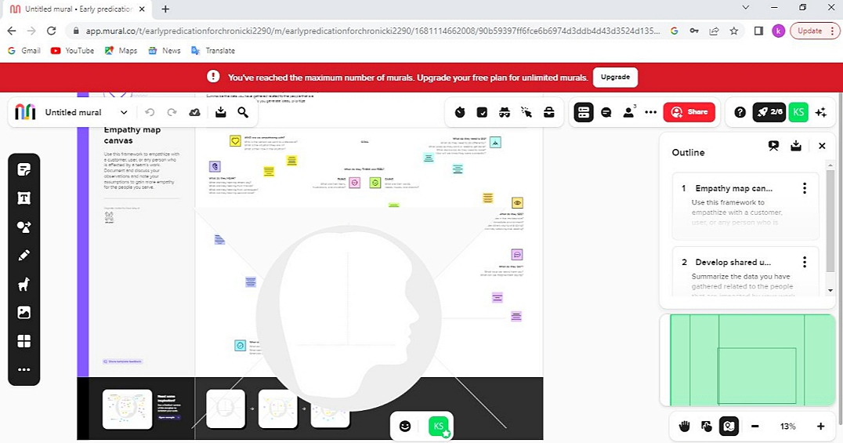

* 1. Ideation and Brainstorming Map

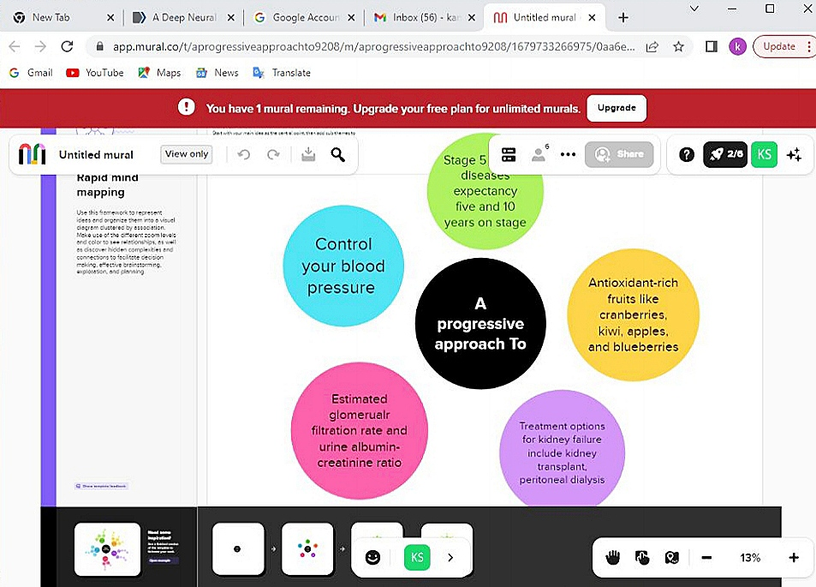

1. RESULT

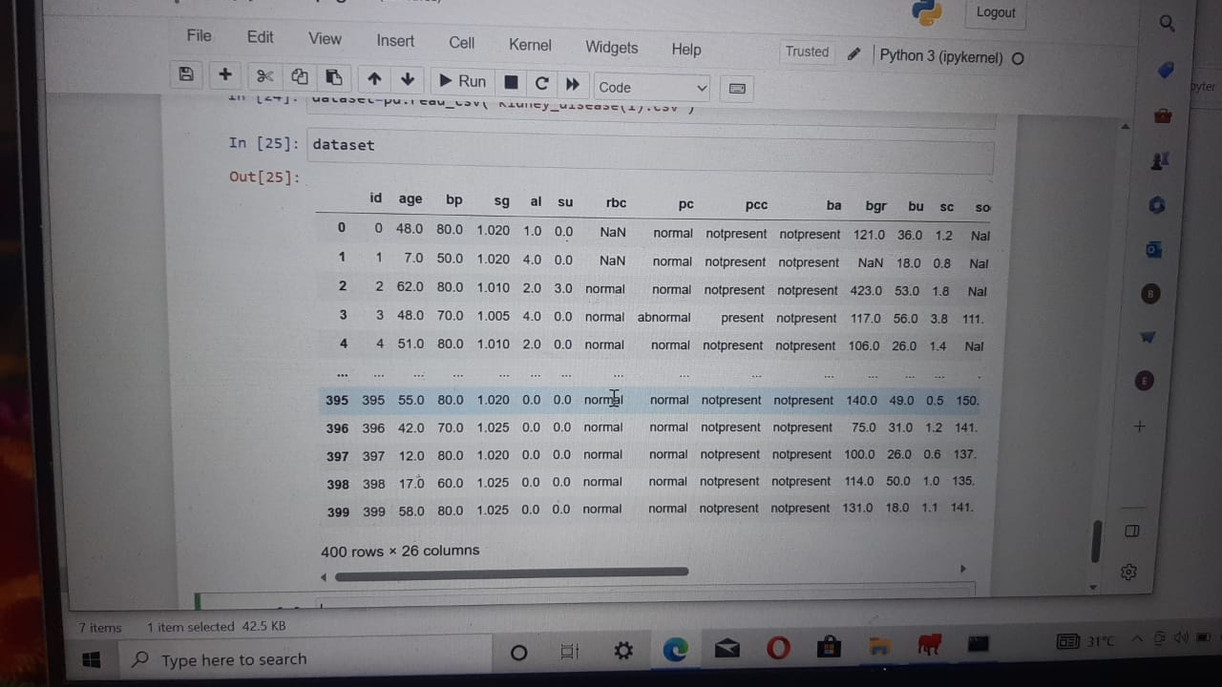

1. ADVANTAGE AND DISADVANTAGE

* Advantage

The goals of early detection are to prevent the progression of chronic kidney disease and its associated complications, with subsequent improvements in patient outcomes and reductions in the impact of chronic kidney disease on healthcare resources.

* Disadvantage

Having CKD **increases the chances of having heart disease and stroke**. Managing high blood pressure, blood sugar, and cholesterol levels—all factors that increase the risk for heart disease and stroke—is very important for people with CKD.

1. APPLICATION

  We will be going through the **Chronic kidney disease dataset** and analysis if an individual will have chronic kidney disease or not.

1. CONCLUSION

This project is a medical sector application which helps the medical practitioners in predicting the CKD disease based on the CKD parameters. It is automation for CKD disease prediction and it identifies the disease, its stages in an efficient and economically manner. It is successfully accomplished by applying the KNN and Naive Bayes algorithms for classification. This classification technique comes under data mining technology.

1. FUTURE SCOPE

In the proposed system, admin assigns Id and password for doctors and receptionists and is intimated manually, so we can add SMS/Email module as a future enhancement where doctors and receptionists receive an SMS or Email regarding the Id and password.

1. APPENDIX

A . Source code

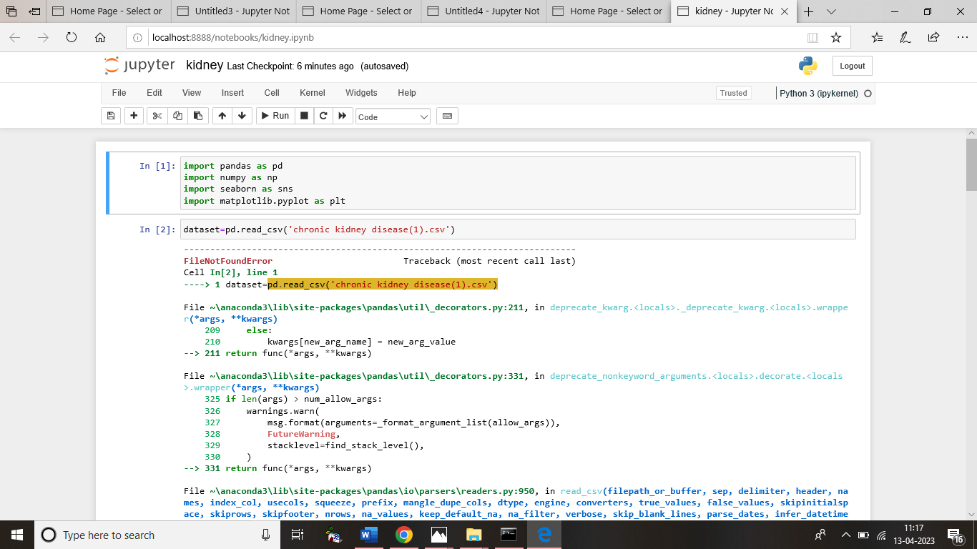

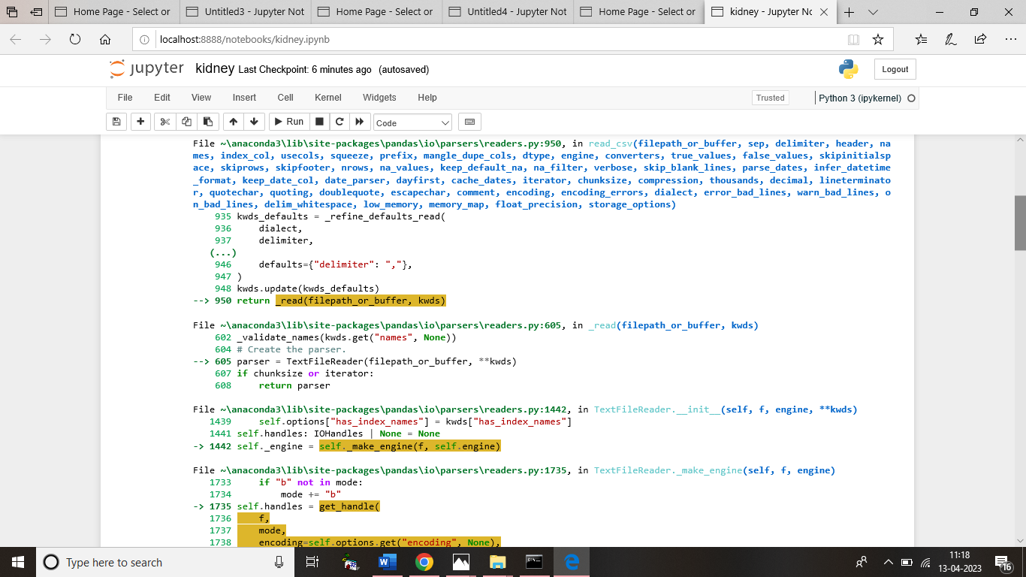

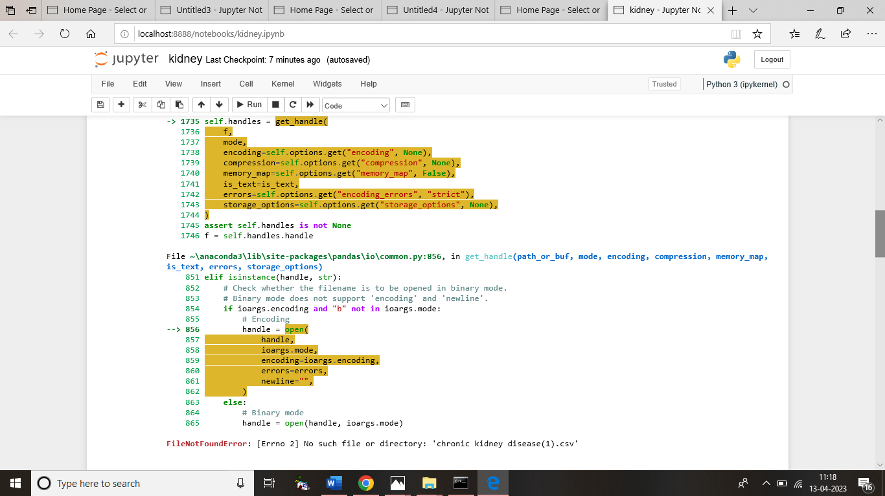

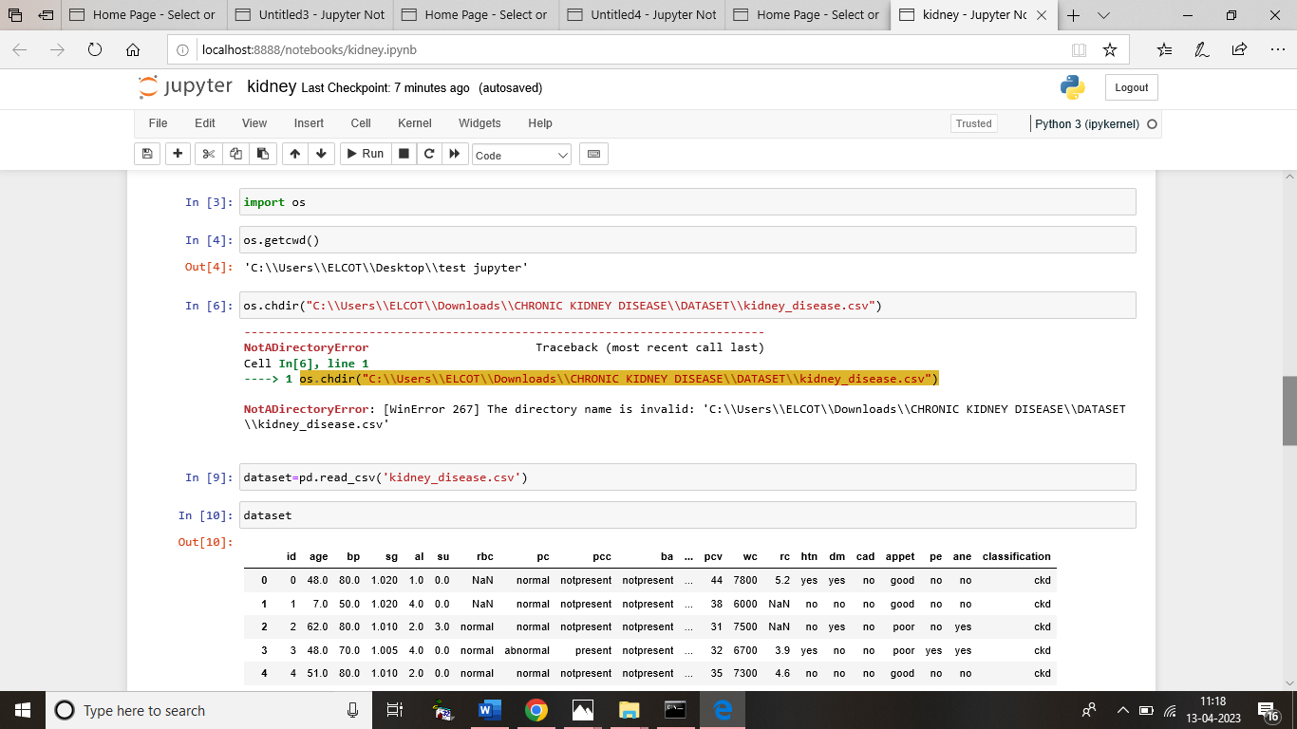

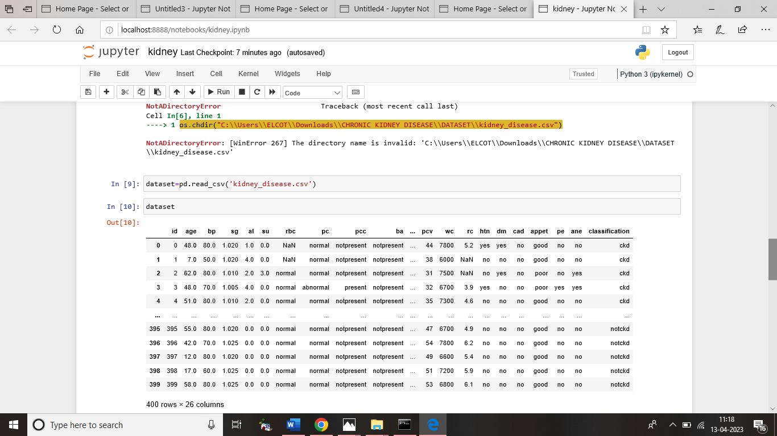

**PRESENTED BY**

**TEAM LEADER**

S.JANCYRANI

**TEAM MEMBERS**

M.GOWSIKA

I.G.HARIPRIYA

J.HENAGRACE